Hulu Clone Project

Project Overview

This project is a simplified video streaming platform inspired by Hulu. The goal is to design and build a scalable web application that allows users to browse, watch, and manage video content while demonstrating full-stack development skills.

Purpose of the Project

This application is designed to:

- Provide users with access to video content
- Allow streaming and playback of videos
- Enable users to save and resume content
- Demonstrate backend, database, and cloud-ready architecture

Core Features

- User registration and login
- Browse videos by category
- Watch videos
- Add/remove videos from watchlist

Technology Stack

Backend
- Node.js

Frontend
- HTML, CSS, JavaScript

Database
- PostgreSQL

Database Schema

Users:
- id (UUID, Primary Key)
- username
- email (unique)
- password
- role (user/admin)

Videos
- id (UUID, Primary Key)
- title
- description
- video_url
- thumbnail_url
- duration

Categories
- id (UUID, Primary Key)
- name (unique)

Watch History
- id (UUID, Primary Key)
- user_id (Foreign Key)
- video_id (Foreign Key)
- progress

Watchlist Table
- user_id (Foreign Key)
- video_id (Foreign Key)

Entity Diagram

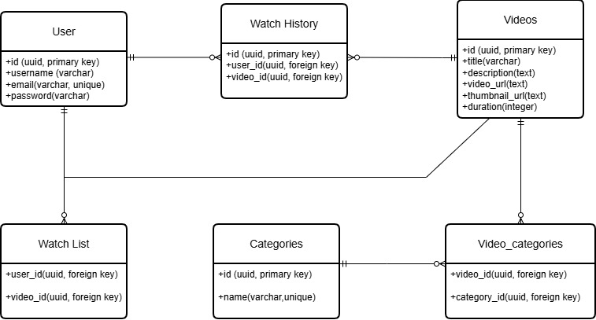

Entity Relationship
The system uses a relational database design to define how different entities are connected. These relationships ensure data consistency and support core application features.

1. Users and Watch History (One-to-Many)
A one-to-many relationship exists between Users and Watch History.
- One user can have multiple watch history records
- Each watch history record belongs to one user
This relationship allows the system to track what each user is watching and their progress.

2. Videos and Watch History (One-to-Many)
A one-to-many relationship exists between Videos and Watch History.
- One video can appear in multiple watch history records
- Each watch history record refers to one video
This enables multiple users to watch the same video while tracking their individual progress.

3. Users and Watchlist (One-to-Many)
A one-to-many relationship exists between Users and Watchlist.
- One user can save multiple videos
- Each watchlist entry belongs to one user
This supports the feature where users can save videos for later viewing.

4. Videos and Watchlist (One-to-Many)
A one-to-many relationship exists between Videos and Watchlist.
- One video can appear in multiple users’ watchlists
- Each watchlist entry refers to one video
This allows multiple users to save the same video.

5. Videos and Categories (Many-to-Many)
A many-to-many relationship exists between Videos and Categories.
- One video can belong to multiple categories
- One category can contain multiple videos
This relationship is implemented using a join table called video_categories, which stores the associations between videos and categories.

Conclusion
This project demonstrates the design and development of a web-based streaming application using a structured backend and relational database.

